TITLE OF THE PAPER

FirstNameOfAuthor1 LastNameOfAuthor1, FirstName2 LastName2 and FirstName3 LastName3∗

Abstract
Text of the abstract: The abstract should summarize the content and conclusions of the paper in less 200 words. It should not contain any references or displayed equations. Typeset the abstract in 10 points, italic, justify alignment.

Keywords: keyword 1, keyword 2, …keyword 6

1. Introduction

Text of the introduction. No more than 15 lines. 12 points, TNR, justify. Present your paper: indicate your topic, make clear what your points are, show the structure of the paper.
Papers are subject to anonymous judgments of two independent referees. The minimum number of pages (including figures, tables, bibliography, notes, appendices) is 5. Any paper of less than 5 pages will not be accepted. Pages will not be numbered. The papers will be typed according with these guidelines.

2. Heading

Papers that focus on specific phenomena and events affecting Romanian economy are particularly encouraged. Because we seek a broad audience, papers should be comprehensible beyond narrow disciplinary bounds.
The paper may have maximum 2 levels of headings, but no more. Authors are encouraged to have their contribution checked for grammar. The text is to be typeset in 11 pt Times New Roman, single spaced, align justify.
Use footnotes for additional explanations. Please keep the number of footnotes to a minimum. Papers should not exceed 5,000 words.

2.1. Subtitles
Position figures and tables at the center, as in the example. Each table and figure should be referred to in your text.

Table no.1

 | 1927 | 1928 | 1929 | 1930 | 1931 | 1932 | 1933 | 1934 | 1935
Britain | 95 | 94 | 100 | 94 | 86 | 89 | 95 | 105 | 114
Canada | 85 | 94 | 100 | 91 | 78 | 68 | 69 | 82 | 90
France | 84 | 94 | 100 | 99 | 85 | 74 | 83 | 79 | 77
Germany | 95 | 100 | 100 | 86 | 72 | 59 | 68 | 83 | 96
Italy | 87 | 99 | 100 | 93 | 84 | 77 | 83 | 85 | 99
Sweden | 85 | 88 | 100 | 102 | 97 | 89 | 93 | 111 | 125
U.S. | 85 | 90 | 100 | 83 | 69 | 55 | 63 | 69 | 79

Source: Statistics, 1900-57 (Paris, OEEC, 1958).

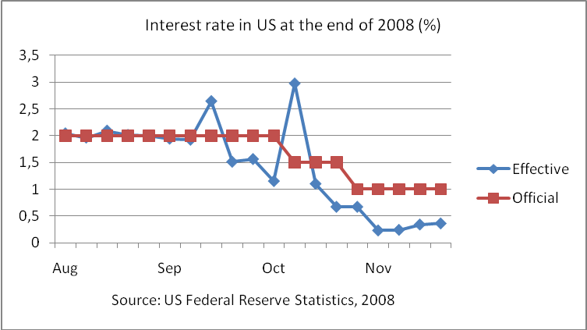

Number equations consecutively with equation numbers in parentheses, as in [1].

3. Conclusion

Conclusion text, TNR 11 pt, Alignment Justify

References

References are to be listed in alphabetical order and cited in the text e.g. [Davenport, (2002)]. Typeset references in TNR 11 pt, Alignment Justify. Follow the style shown in these examples:

Author. year. Title of the book, Publisher.
Author. year. “Title of the paper”. Title of the journal, vol.(no.): pp.
Author. year. “Title of the paper”. In Title of the proceedings, Publisher, Location, pp.

Sample:

Sachs, Jeffrey. 2005. The End of Poverty: Economic Possibilities for Our Times. New
York: Penguin Press.
Easterly, William. 2006. “Planners versus Searchers in Foreign Aid”. Asian Development
Review 23(1): 1-35.

Hoff, Karla and Stiglitz, Joseph. 2001. “Modern Economic Theory and Development”. In

Meier, G. and Stiglitz, J. E. eds. Frontiers of Development Economics: The

Future in Perspective. New York: Oxford University Press, pp. 389-485.

 Author1 is (Assistant, Associate) Professor of ... at the... [Name of institution], [city]. E-mail address:... Author2 is (Assistant, Associate) Professor of ... at the... [Name of institution], [city].

